Due June 18, 11:59PM

* 10 marks
* 20% deducted each day this is late.
* Please submit your Angular application in zipped archive.

With the help of Angular directives, scope, models and the controller perform the following tasks:

* When the page loads the weather information is not initially displayed. (1 mark)
* Clicking the city button displays the correct weather for that city. Only one weather summary appears at a time. You can decide where you wish to display the weather information. (3 marks)
* Clicking the sort button sorts the data as requested by city. (2 marks)
* Clicking the Fahrenheit or Celsius options displays temperatures in Celsius or Fahrenheit as requested. Your application performs the required calculation to convert temperatures to Celsius. (I recommend calling a function in the controller to perform the calculation to Celsius or to switch back to Fahrenheit as the user chooses. ) (4 marks)

Your application could look something like this:

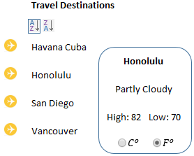

Please use the starter hint and do not change the city and weather data.